**Mount Lawley Senior High School**

**Physical Science 2022**

Forces – Year 7

**Section 1 – Multiple Choice (20 marks)**

**Select the BEST answer on the answer.**

**1. When forces are unbalanced they can:**

1. change the shape of an object.
2. change the speed of an object.
3. change the direction of an object.
4. all of the above.

**2. Consider the following forces**

***1) Electrostatic***

***2) Frictional***

***3) Gravitational***

***4) Magnetic***

**The non-contact forces are:**

1. 1,2,3 & 4
2. 1 & 4
3. 1,3 & 4
4. 1,2 & 4

**3. Friction is a force that:**

a. Opposes an object’s motion.

b. Does not exist when surfaces are very smooth.

c. Decrease with larger mass.

d. Does not require contact.

**4. Which of the following increases the amount of friction?**

a. Making the surfaces smoother.

b. Making the surfaces rougher.

c. Putting oil on the surfaces.

d. Heating the surfaces.

**5. Friction can be reduced by:**

a. increasing surface area.

b. increasing the roughness of the surfaces in contact.

c. using a lubricant.

d. exerting greater force.

**6. When you walk across the ground and push on it with your feet:**

a. There is no effect on the ground.

b. The ground pushes back less strongly than your feet.

c. The ground pushes back more strongly than your feet.

d. The ground pushes back on your feet with equal force.

**7. Which is an example of friction that is helpful?**

a. Wearing an aerodynamic helmet when riding a bicycle.

b. Tyres moving a car forward on a road.

c. Hole developing in your socks.

d. Car engine parts wearing out.

|  |  |
| --- | --- |
| TIME (seconds) | VELOCITY (m/s) |
| 0 | 8 |
| 1 | 6 |
| 2 | 4 |
| 3 | 2 |
| 4 | 0 |

**8. Which best describes the motion of the object recorded in data table below?**

a. it does not move

b. it maintains a constant speed

c. it is accelerating

d. it is decelerating

**9. Describe the motion of a person not wearing a seat belt if the car stops suddenly:**

a. The person and car will stop together.

b. The person will stop faster than the car because they are lighter.

c. The car will stop and the person will keep moving forward because of inertia.

d. The car will stop and the person will speed up.

**10. What is the net (resultant) force on the box shown below?**

30 N

20 N

60 N

1. 10 N to the left
2. 10 N to the right
3. 60 N to the left
4. 50 N to the right

**11. A crumpled piece of paper hits the ground before a flat sheet of paper because:**

a. The acceleration of gravity is greater on the crumpled paper.

b. There is more air resistance against the flat paper.

c. The crumpled paper is more massive.

d. The crumpled paper is less massive.

**12. A bar magnet is divided in two pieces. Which of the following statements is true about the force between the broken pieces if they face each other with a small separation?**

1. There is an electric attractive force between the broken pieces.
2. There is a magnetic repulsive force between the broken pieces.
3. There is a magnetic attractive force between the broken pieces.
4. There is no force between the broken pieces since they are

demagnetized.

**13. Which would hit the ground first if dropped from the same height in a vacuum chamber —a feather or a metal bolt?**

1. the feather
2. the metal bolt
3. They would hit the ground at the same time.
4. They would both float in a vacuum as there is no gravity

**14. A car moving in a straight line at constant speed:**

a. has no unbalanced force acting on it.

b. is decelerating.

c. is accelerating.

d. must be on a downhill slope.

**15. What is the direction of magnetic field lines outside a magnet?**

a. South pole to north pole

b. North pole to south pole

c. West pole to east pole

d. East pole to west pole

**16. For an aircraft to successfully take off, the lift force provided by its wings must be greater than the aircraft’s weight force. The thrust provided by its engine must also be greater than any drag forces. To coast in the air, forces are balanced. A successful landing is the reverse process of the launch.**

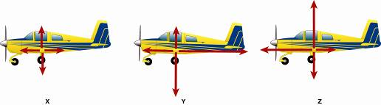

**The correct sequence (order) of diagrams that shows the combination of force pairs required for an aircraft take-off, cruising at altitude, and a safe landing is:**

1. X, Y, Z
2. Y, X, Z
3. Z, Y, X
4. Z, X, Y

**Use the following information to answer questions 17 and 18:**

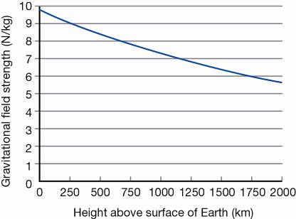**The gravitational field strength at various distances from the surface of the Earth is shown in the following graph**

**17. From this graph you can conclude that:**

1. The gravitational field strength of the Earth does not change as you travel further away from Earth’s surface.
2. The gravitational field strength of the Earth increases as you travel further away from Earth’s surface.
3. The gravitational field strength of the Earth decreases as you travel further away from Earth’s surface.
4. The gravitational field strength of the Earth only extends to 2000 km above the Earth’s surface.

**18. If you were to weigh an apple at a height of 1000 km above the surface of the Earth:**

a. the reading would be the same as it is on the Earth’s surface.

b. the reading on the scales would be greater.

c. the reading on the scales would be lower.

d. there would be no reading on the scales.

**19. A car is slowing down so that it can stop at a traffic light. What must be true about the forces acting on the car?**

1. The forces are balanced and the net force is backwards.
2. The forces are balanced and there is no net force.
3. The forces are unbalanced and the net force is forwards.
4. The forces are unbalanced and the net force is backwards.

**20. If two north poles of two magnets are placed near each other ...**

1. Nothing will happen
2. They will attract
3. They will be demagnetised
4. They will repel

**- End of Multi-Choice Section –**

|  |  |
| --- | --- |
| Mount Lawley Senior High School - Wikipedia | **Mount Lawley Senior High School** |
| **Year 7 2022 – Physical Science – Forces Test** |
| Name: ______________________________________________________  Class: ________________ Date:________________________ |

**Section A: Multiple Choice 20 Marks**

**Please SHADE the best suited answer in PEN**

*To change your answer put a X through the wrong answer*

1. A B C D
2. A B C D
3. A B C D
4. A B C D
5. A B C D
6. A B C D
7. A B C D
8. A B C D
9. A B C D
10. A B C D
11. A B C D
12. A B C D
13. A B C D
14. A B C D
15. A B C D
16. A B C D
17. A B C D
18. A B C D
19. A B C D
20. A B C D

**Multiple Choice: _________ /20**

**Short Answer: _________ /27**

**TOTAL: ________ /47**

***Section 2 - Short Answers (27 marks)***

1. ***The force that allows things to float is called buoyancy. Ship A and Ship B both have a buoyancy force acting upwards and a weight force acting downwards***.

1. **Ship A Ship B**
2. 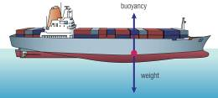 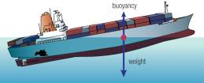

***Describe*** *what you think will happen to each ship, giving reasons for your answers****. (4 marks)***

_________________________________________________________________________________________________________________________________________________________________________________________________________________________________________________________________________________________________________________________________________________________________________________________________________________________________________________________________________________________________________________________________________________________________________________________________________

**Will float (1 mark) because weight and buoyancy forces are balanced (1 mark)**

*Must mention names not just ‘forces’. Must say balanced. ‘Equal’ etc = ½ mark*

**Will sink (1 mark) because the weight is stronger than the buoyancy force (1 mark) OR NET FORCE is downwards.**

2. ***Draw the forces acting in the following scenarios including whether they are balanced or unbalanced: (3 marks)***





Car braking

Parachute travelling at a steady speed

***Circle the correct force below:***

Balanced/Unbalanced Balanced/Unbalanced

1 mark for each for correct representation of arrows

½ mark for correct circling of balanced/unbalanced

***3.a) What is gravity?***   ***(1 mark)***

Attraction/pull between objects due to **curvature of spacetime**

_____________________________________________________________________________________________________________________

_____________________________________________________________________________________________________________________

_____________________________________________________________________________________________________________________

**b)** ***Is it possible for the gravitational force between two 50 kg objects to be less than the  
 gravitational force between a 50 kg object and a 5 kg object? Explain. (1 mark)***

***(Hint draw a diagram to  
 help explain your answer)***

___________________________________________________________________________________________________________________

Yes – **by increasing distance between the two objects 50kg objects** – reduces gravitational force between them 1 mk

_____________________________________________________________________________________________________________________

_____________________________________________________________________________________________________________________

***c. If the Earth doubled in mass (but stayed the same size) predict how the Earth’s gravitational field strength would change? (1 mark)***

increased mass would **increase spacetime curvature**

Therefore **increase the strength of the gravitational field** around Earth so force of **gravity would increase**

_____________________________________________________________________________________________________________________

_____________________________________________________________________________________________________________________

_____________________________________________________________________________________________________________________

***4. Briefly describe three different types of forces you could exert/experience when riding a bike*  *(3 marks)***

(no mark for listing ‘friction only – must give a description)

Applied force – by pedalling,

Friction – tyres on road, or when applying brakes,

Air resistance – friction in opposite direction of motion due to collisions with air particles or similar answers)

*Gravity and weight description = ½ mark. It is constant, not specific to riding a bike.*

Or suitable description – not listing

__________________________________________________________________________________________________________________________________________________________________________________________________________________________________________________________________________________________________________________________________________________________________________________________________________________________________________________________________________________________________________________________________________________________________________________________________________________________________________________________________________________________________________________________________________________________________________________________________________________________________________________

***5. Calculation – show full working out***

***Rocco has a mass of 52kg. The gravitational field strength on Earth is 10 m/s2 and on the Moon it is 1.6 m/s2.***

***a) What is Rocco’s weight on Earth? (2 marks)***

F = m x a ( ½ mark for formula)

= 52 x 10 ( ½ mark for substitution)

= 520 N ( ½ mark for 520, ½ mark for units)

***b) What would Rocco’s weight be on the Moon? ( 1 mark)***

F = m x a

= 52 x 1.6 ( ½ mark for both formula & substitution)

= 83.2 N ( ½ mark for both answer & units )

***c) Explain the difference between Rocco’s mass and weight*** ***on the Earth & the Moon. (2 marks)***

Rocco’s **mass is the amount of matter** in his body – **stays constant** regardless of location - 1mk

Rocco’s **weigh**t will be greater on the Earth due to the **greater gravitational force caused by the Earth’s larger mass** (bending spacetime) compared with smaller mass of the Moon causing less gravitational force– 1 mk

____________________________________________________________________________________________________________________________________________________________________________________________________________________________________________________________________________________________________________________________________________________________________________________________________________________________________________________________________________________

***6. A rock rolls halfway down a hill and comes to a stop.***

***Name what two forces are acting on the rock once it stops and explain your answer. (2 marks)***

Forces = **friction and weight** force of rock – 1 mark for both

as the rock is only halfway down friction force balanced against weight/gravitational force pulling mass toward Earth - 1 mark

**Air resistance is when object are MOVING**

_________________________________________________________________________________________________________________________________________________________________________________________________________________________________________________________________________________________________________________________________________________________________________________________________________________________________________________________________________________________________________________________________________________________________________________________________________

***7***. ***Beck carried out an investigation to find out the best way of lowering the amount of friction on a ramp. She sets up 5 identical wooden ramps and covers them in different substances. She then records the time it takes a wooden block to slide down the ramp.***

The table below shows Beck’s results:

a. ***On the grid below, draw a graph showing the data. (5 marks)***

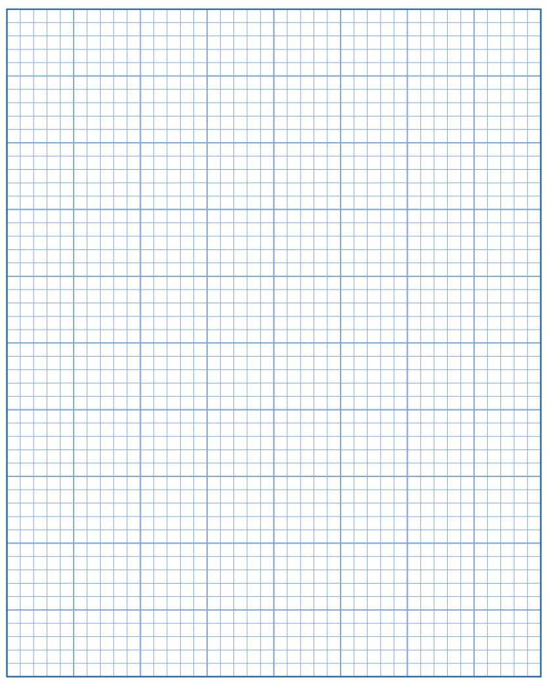

GRAPH MARKING KEY

1 mark for correct title

1 mark each for correct x and y axis title ( ½ mark goes to correct units, ½ title)

1 mark correct scales on both axis

1 mark for correct graphing of data.

DEDUCTIONS

-1 for pen not pencil.

-1 for free hand and not using a ruler

-1 for using line graph not column

***b. Using the data or your graph, write a conclusion for the investigation. (2 marks)***

½ mark for stating cooking oil reduces friction the most   
½ mark stating cook oil takes 2.5 seconds  
½ stating syrup reduces friction the least   
½ stating it takes 6.5 seconds

______________________________________________________________________________________________________________________________________________________________________________________________________________________________________________________________________________________________________________________________________________________________________________________________________________________________________________________________________________________________________________________________________________________________________________________________________________________________________________________________________________________________________________________________

**- End of Test -**